Dayson L Delfin | WD-301

UI Screenshot

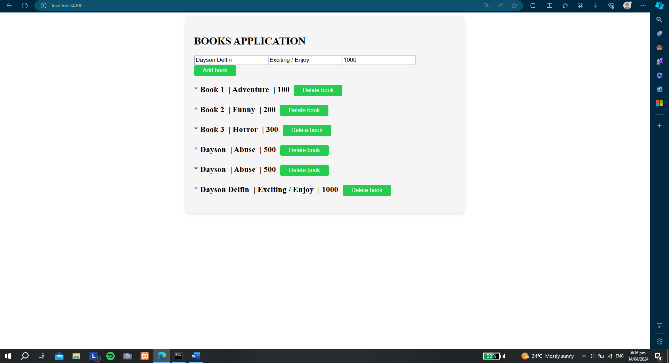

MongoDB Database Screenshot

